**Experiment – 9**

**VIEWS**

**Aim:**

* Create table students with attributes id, name and department.
* Display
* Create view and select
* Insert values
* Create view with check option
* Insert values and alter table

**Components:**

* A view is a subset of a database that is generated from a
* query and stored as a permanent object.
* Instance: It is the collection of information stored in a
* database at a particular moment.
* Entity: Object that is relevant to given system.
* Represented as rectangle.
* Attribute: Trait of an entity, relationship or other attribute.
* Represented by oval.

**CODE WITH SOLUTIONS**

* Create table students with attributes id, name and department.
* Display

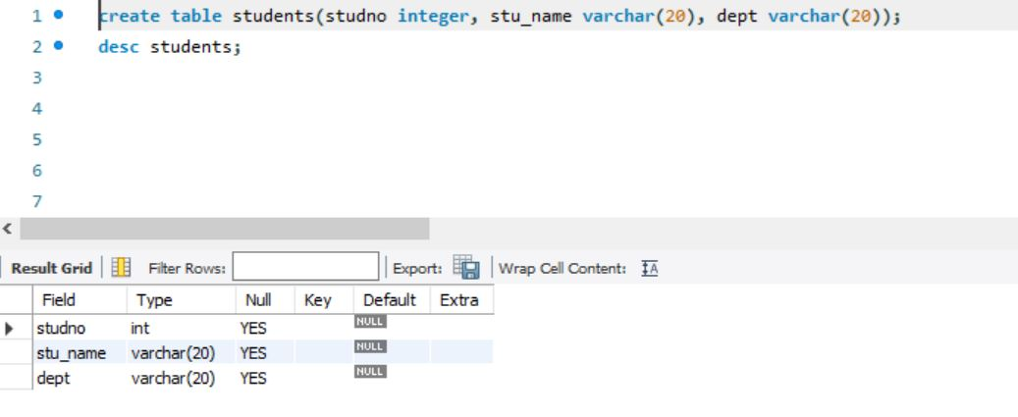

* Create view and select
* Insert values

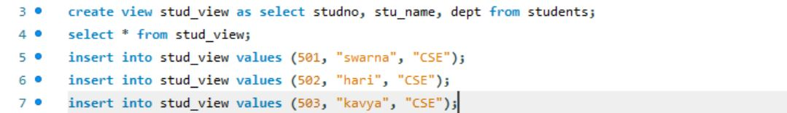

* Create view with check option
* Insert values and alter table

